**Lab Record Of Web Design**

Submitted to Dr. Arup Roy

Submitted by Arpit Agarwal

Section-A

Enrollment no.-A20405220102

Amity University Rajasthan,

Jaipur, India

1. Aim: Design a HTML page using all the basic tags.

Code:

<html>

<head>

<title>First Web Page</title>

</head>

<body text="white"

background="tree-736885__480.jpg">

<style>

body{

background-repeat: no-repeat;

background-position: fixed;

background-size: cover;

}

</style>

<p>NATURE<br> Nature, in the broadest sense, is the natural, physical, material world or universe.

"Nature" can refer to the phenomena of the physical world, and also to life in general.

The study of nature is a large, if not the only, part of science.

Although humans are part of nature, human activity is often understood as a separate category from other natural phenomena.</p>

</body>

</html>

Output:

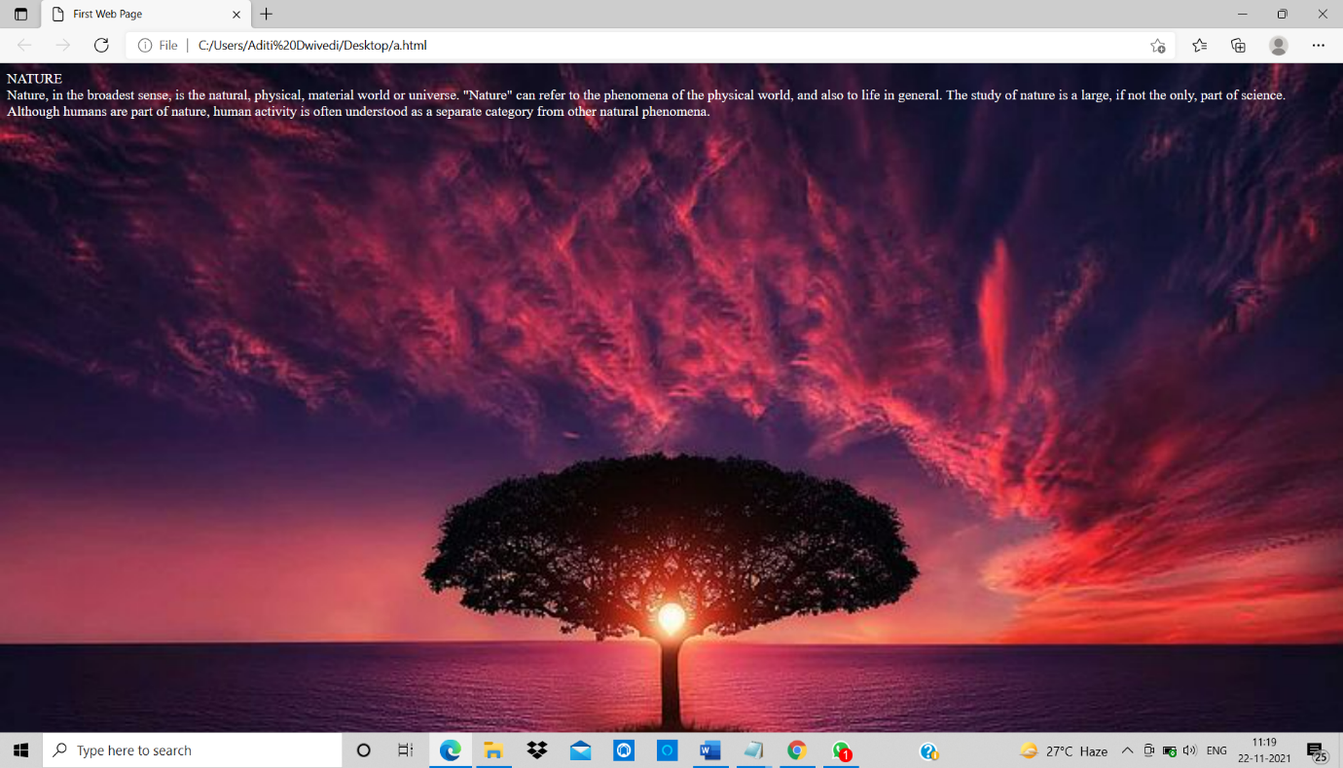

1. Aim: Design a page containing your educational qualification in a table.

Code:

<html>

<head>

<title>First Web Page</title>

</head>

<body>

<table border ="5" align="center" width="70%">

<th> Name </th>

<th> Roll </th>

<th> Result </th>

<tr>

<td> Arpit </td>

<td> 104 </td>

<td> Pass </td>

</tr>

<tr>

<td> Aman </td>

<td> 108 </td>

<td> Pass </td>

</tr>

<tr>

<td> Anshika </td>

<td> 112 </td>

<td> Fail </td>

</tr>

</table>

</body>

</html>

Output:

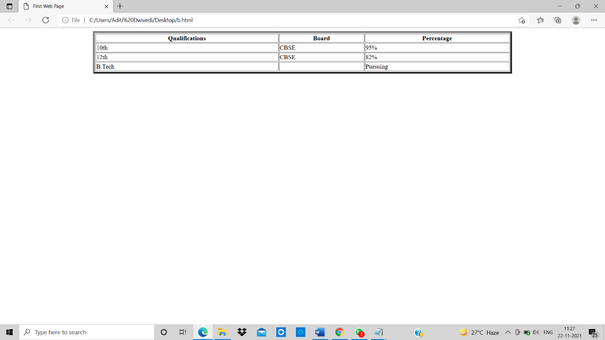

1. Aim: Design a page containing an ordered list/unordered list.

Code:

<!DOCTYPE html>

<html>

<head>

<title> First Web Page</title>

</head>

<body>

<h1>Ordered List</h1>

<ol type=1>

<li>Keyboard</li>

<li>Mouse</li>

<li>Printer</li>

<li>Monitor</li>

</ol>

<ol type=A>

<li>Keyboard</li>

<li>Mouse</li>

<li>Printer</li>

<li>Monitor</li>

</ol>

<ol type=a>

<li>Keyboard</li>

<li>Mouse</li>

<li>Printer</li>

<li>Monitor</li>

</ol>

<ol type=I>

<li>Keyboard</li>

<li>Mouse</li>

<li>Printer</li>

<li>Monitor</li>

</ol>

<ol type=i>

<li>Keyboard</li>

<li>Mouse</li>

<li>Printer</li>

<li>Monitor</li>

</ol>

<ol start=6>

<li>Keyboard</li>

<li>Mouse</li>

<li>Printer</li>

<li>Monitor</li>

</ol>

<ol reversed= reversed>

<li> Keyboard </li>

<li> Mouse </li>

<li> Printer </li>

<li> Monitor </li>

</ol>

<h1>Unordered List</h1>

<ul type= "disc">

<li> Keyboard </li>

<li> Mouse </li>

<li> Printer </li>

<li> Monitor </li>

</ul>

<ul type="circle">

<li> Keyboard </li>

<li> Mouse </li>

<li> Printer </li>

<li> Monitor </li>

</ul>

<ul type="square">

<li> Keyboard </li>

<li> Mouse </li>

<li> Printer </li>

<li> Monitor </li>

</ul>

<ul type="none">

<li> Keyboard </li>

<li> Mouse </li>

<li> Printer </li>

<li> Monitor </li>

</ul>

</body>

</html>

Output:

1. Aim: Design a form in HTML to enter different attribute of student information.

Code:

<!DOCTYPE html>

<html>

<head>

<title>First Web Page</title>

</head>

<body>

<form>

Username: <input type="text"> <br>

Password: <input type="password"> <br>

Gender: <input type="radio" name=="r1"> Male

<input type="radio" name=="r1"> Female <br>

Language: <input type="checkbox">Hindi

<input type="checkbox">English

<input type="checkbox">French <br>

Address: <textarea> </textarea> <br>

<input type="submit" value="Register">

<input type="reset">

</form>

</body>

</html>

Output:

1. Aim: Design a home page for ASE using Frame.

Code:

<!DOCTYPE html>

<html>

<head>

<title>First Frame</title>

</head>

<frameset rows="30%,70%">

<frame src="x.html">

<frameset cols="20%,80%" >

<frame src="y.html">

<frame src="a.html">

</frameset>

</frameset>

</html>

Output:

8.Aim: Write a function in Javascript for input validation.

Code:

<script>

function validateform(){

var name=document.myform.name.value;

var password=document.myform.password.value;

if (name==null || name==""){

alert("Name can't be blank");

return false;

}else if(password.length<6){

alert("Password must be at least 6 characters long.");

return false;

}

}

</script>

<body>

<form name="myform" method="post" action="abc.jsp" onsubmit="return validateform()" >

Name: <input type="text" name="name"><br/>

Password: <input type="password" name="password"><br/>

<input type="submit" value="register">

</form>

Output:

9. Aim: Write a function in Javascript to calculate monthly installation of the loan.

Code:

<head><title>JavaScript Loan Calculator</title></head>

<body bgcolor="white">

<!--

This is an HTML form that allows the user to enter data and allows

JavaScript to display the results it computes back to the user. The

form elements are embedded in a table to improve their appearance.

The form itself is given the name "loandata", and the fields within

the form are given names such as "interest" and "years". These

field names are used in the JavaScript code that follows the form.

Note that some of the form elements define "onchange" or "onclick"

event handlers. These specify strings of JavaScript code to be

executed when the user enters data or clicks on a button.

-->

<form name="loandata">

<table>

<tr><td colspan="3"><b>Enter Loan Information:</b></td></tr>

<tr>

<td>1)</td>

<td>Amount of the loan (any currency):</td>

<td><input type="text" name="principal" size="12"

onchange="calculate();"></td>

</tr>

<tr>

<td>2)</td>

<td>Annual percentage rate of interest:</td>

<td><input type="text" name="interest" size="12"

onchange="calculate();"></td>

</tr>

<tr>

<td>3)</td>

<td>Repayment period in years:</td>

<td><input type="text" name="years" size="12"

onchange="calculate();"></td>

</tr>

<tr><td colspan="3">

<input type="button" value="Compute" onclick="calculate();">

</td></tr>

<tr><td colspan="3">

<b>Payment Information:</b>

</td></tr>

<tr>

<td>4)</td>

<td>Your monthly payment will be:</td>

<td><input type="text" name="payment" size="12"></td>

</tr>

<tr>

<td>5)</td>

<td>Your total payment will be:</td>

<td><input type="text" name="total" size="12"></td>

</tr>

<tr>

<td>6)</td>

<td>Your total interest payments will be:</td>

<td><input type="text" name="totalinterest" size="12"></td>

</tr>

</table>

</form>

<!--

This is the JavaScript program that makes the example work. Note that

this script defines the calculate() function called by the event

handlers in the form. The function refers to values in the form

fields using the names defined in the HTML code above.

-->

<script language="JavaScript">

function calculate() {

// Get the user's input from the form. Assume it is all valid.

// Convert interest from a percentage to a decimal, and convert from

// an annual rate to a monthly rate. Convert payment period in years

// to the number of monthly payments.

var principal = document.loandata.principal.value;

var interest = document.loandata.interest.value / 100 / 12;

var payments = document.loandata.years.value * 12;

// Now compute the monthly payment figure, using esoteric math.

var x = Math.pow(1 + interest, payments);

var monthly = (principal*x*interest)/(x-1);

// Check that the result is a finite number. If so, display the results.

if (!isNaN(monthly) &&

(monthly != Number.POSITIVE_INFINITY) &&

(monthly != Number.NEGATIVE_INFINITY)) {

document.loandata.payment.value = round(monthly);

document.loandata.total.value = round(monthly * payments);

document.loandata.totalinterest.value =

round((monthly * payments) - principal);

}

// Otherwise, the user's input was probably invalid, so don't

// display anything.

else {

document.loandata.payment.value = "";

document.loandata.total.value = "";

document.loandata.totalinterest.value = "";

}

}

// This simple method rounds a number to two decimal places.

function round(x) {

return Math.round(x*100)/100;

}

</script>

</body>

</html>

Output:

10. Aim: Write an input form and save its data in a database using ASP.

Code:

<!DOCTYPE html>

<html>

<head>

<meta charset="utf-8" />

<title>Add a Movie</title>

</head>

<body>

 <h1>Add a Movie</h1>

 <form method="post">

    <fieldset>

      <legend>Movie Information</legend>

      <p><label for="title">Title:</label>

         <input type="text" name="title" value="@Request.Form["title"]" />

</p>

      <p><label for="genre">Genre:</label>

         <input type="text" name="genre" value="@Request.Form["genre"]" />

</p>

      <p><label for="year">Year:</label>

         <input type="text" name="year" value="@Request.Form["year"]" />

</p>

      <p><input type="submit" name="buttonSubmit" value="Add Movie" /></p>

    </fieldset>

  </form>

</body>

</html>

Output:

11. Aim: Display the data stored in database in tabular form on the page.

Code:

<html>

<head>

<title>Insert Data and Display in Table </title>

</head>

<form action="" method="post" name="form1">

<table width="25%" border="0">

<tbody><tr>

<td>Product Name</td>

<td><input type="text" name="pname"></td>

</tr>

<tr>

<td>Product Code</td>

<td><input type="text" name="pcode"></td>

</tr>

<tr>

<td>Product Price </td>

<td><input type="text" name="pprice"></td>

</tr>

<tr>

<td></td>

<td><input type="submit" name="Submit" value="Add"></td>

</tr>

</tbody></table>

</form>

</html>

Output:

